Module 4: AI for Business
4.1 Introduction to AI
What is Artificial Intelligence (AI)?
Artificial Intelligence (AI) is the ability of machines to perform tasks that normally require human intelligence, such as learning, reasoning, problem-solving, and decision-making.
What is Machine Learning (ML)?
Machine Learning is a subset of AI where systems learn from data and improve their performance without being explicitly programmed.
Example:
- Netflix recommends movies based on your watching history.
- Email spam filters learn to identify spam messages.
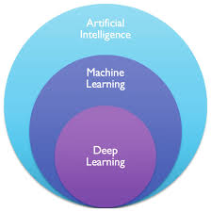
What is Generative AI?
Generative AI creates new content such as text, images, videos, code, and audio.
Examples:
- ChatGPT generates text.
- AI image generators create images from descriptions.
- AI coding assistants generate programming code.
Business Use Cases of AI
- Customer Support Chatbots
- Fraud Detection
- Sales Forecasting
- Personalized Marketing
- Inventory Management
- HR Recruitment

AI website for different work
1.https://songgenerator.io/app (for song creation from text)
2.Eleven Lab(voice generation)
3.Lyrebird(Voice generation)
4.Runway(for video creation)
5.Sora(for video creation)
6.openart.ai(image creation)
7.app.aistudios.com(text-to-video)
8.https://www.craiyon.com/ (for image generation free)
9.https://deepai.org/ (for image/video generation)
10. https://stablediffusionweb.com/app/image-generator (Text to image)

Image: AI in Business
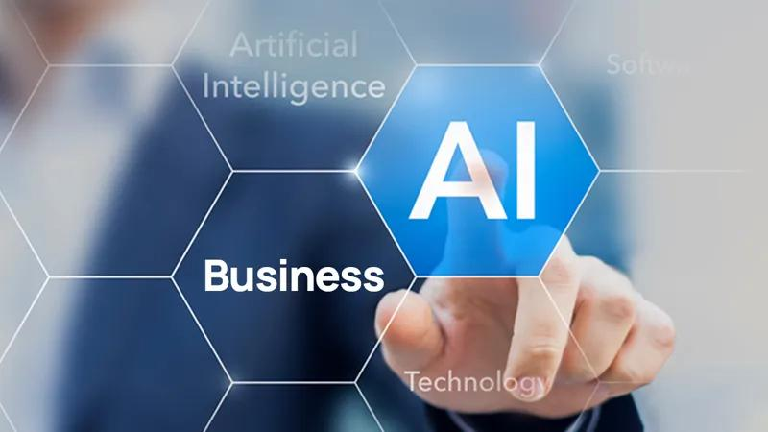
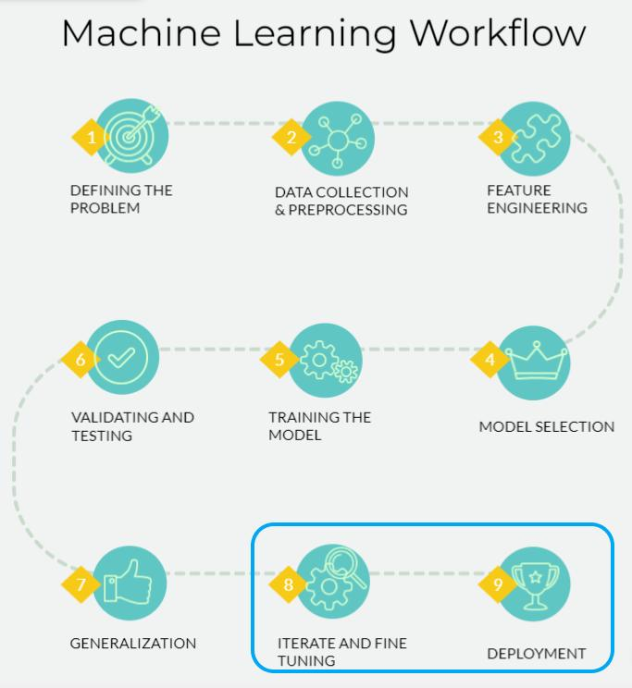
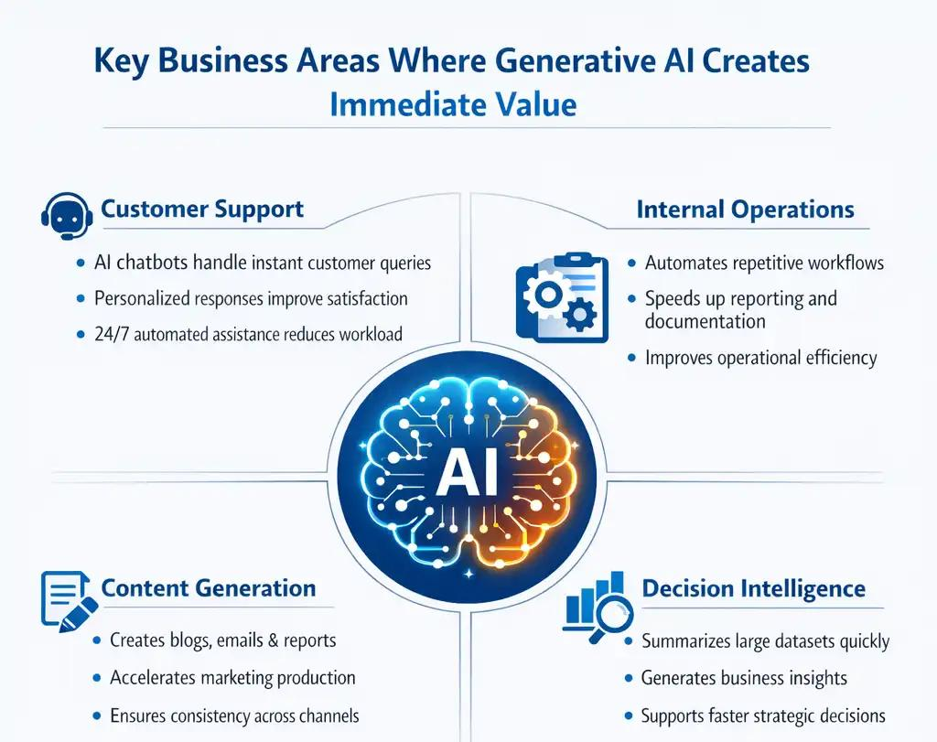

4.2 AI Tools for Business
ChatGPT and AI Tools Usage
Popular AI Tools
Tool | Purpose
ChatGPT | Content generation, Q&A
Microsoft Copilot | Productivity assistance
Google Gemini | Research and content creation
Claude | Business writing and analysis
Midjourney | Image generation
Example
Prompt:
Write a professional email to customers announcing a new product launch.
Output:
AI generates a complete business email in seconds.
Benefits
- Saves time
- Improves productivity
- Generates ideas quickly
- Supports decision-making
Image: AI Business Tools
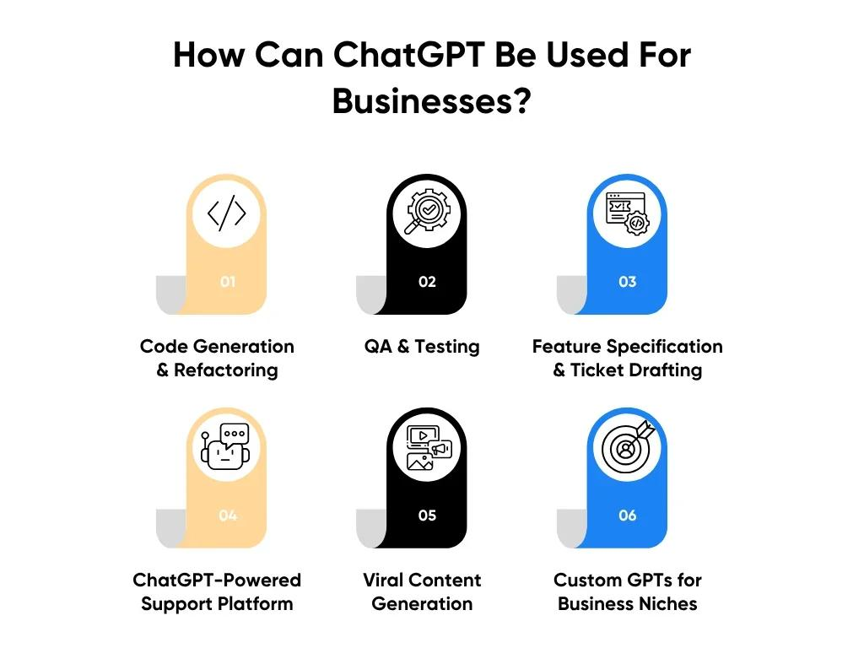
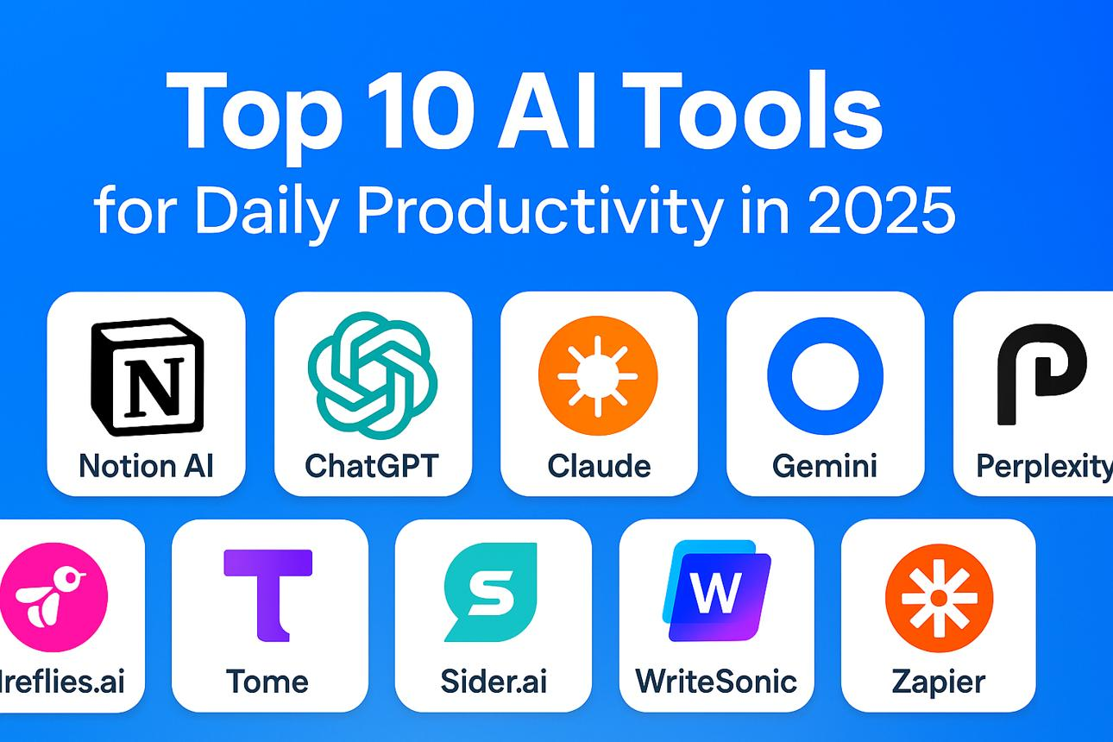
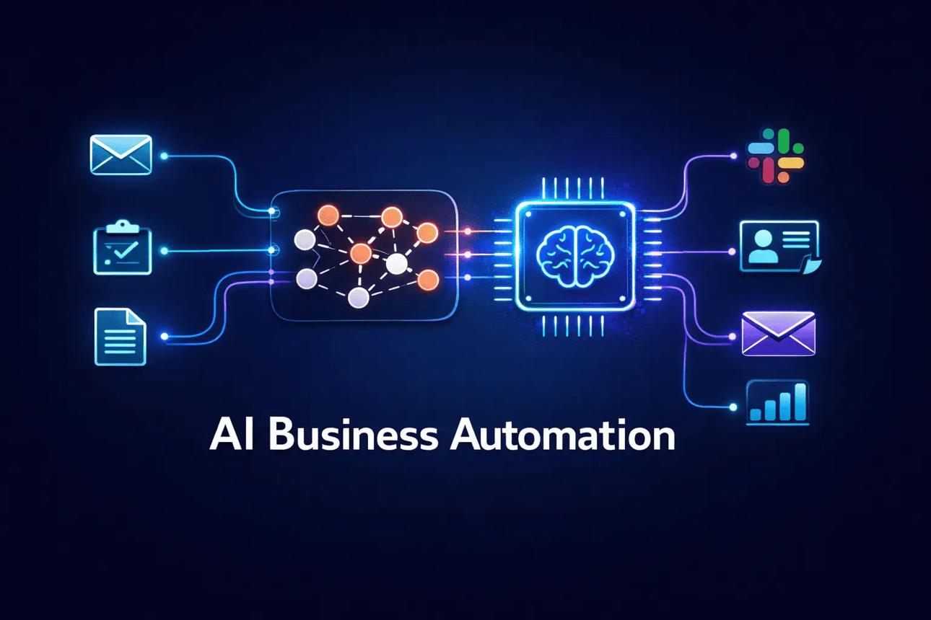
Prompt Engineering Basics
Prompt Engineering is the process of writing effective instructions to get better results from AI.
Basic Formula
Role + Task + Context + Format
Example
❌ Poor Prompt:
Write about sales.
✅ Better Prompt:
Act as a sales manager and create a monthly sales report summary for a retail company in 200 words.
Tips
- Be specific.
- Provide context.
- Mention output format.
- Include examples if needed.
Example Prompt
Create a Power BI dashboard summary showing monthly sales trends and top-performing products.
Image: Prompt Engineering
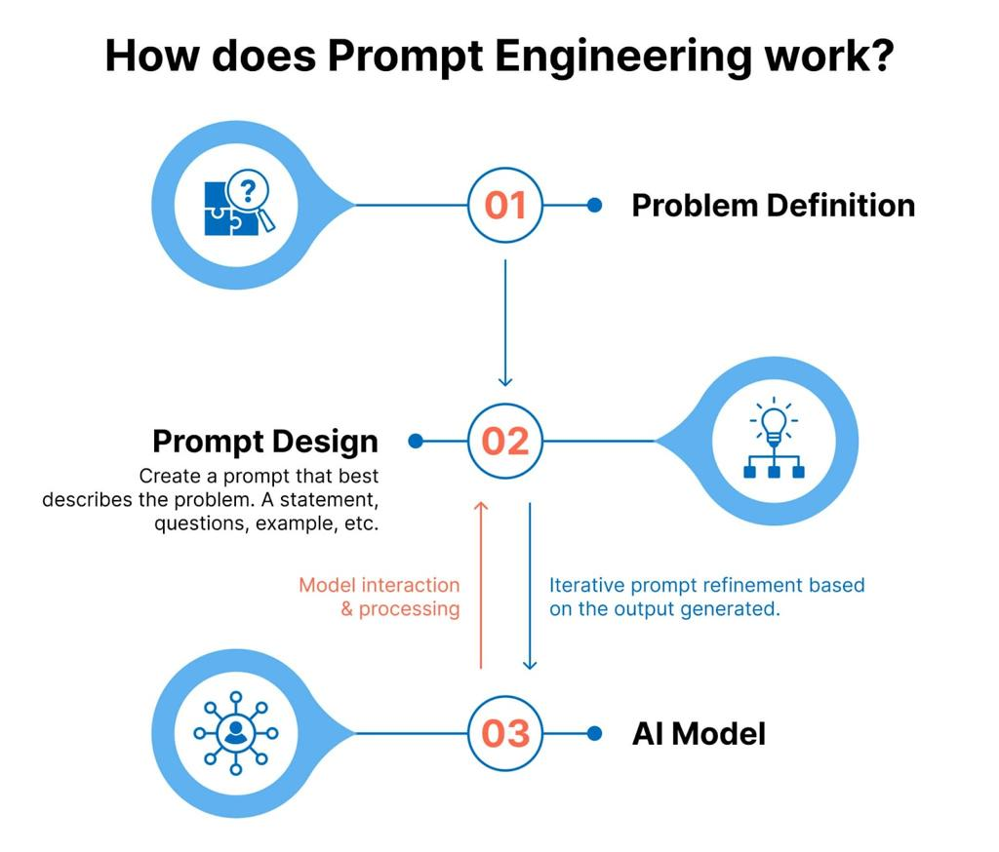
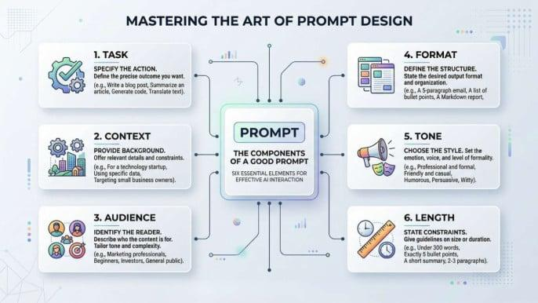
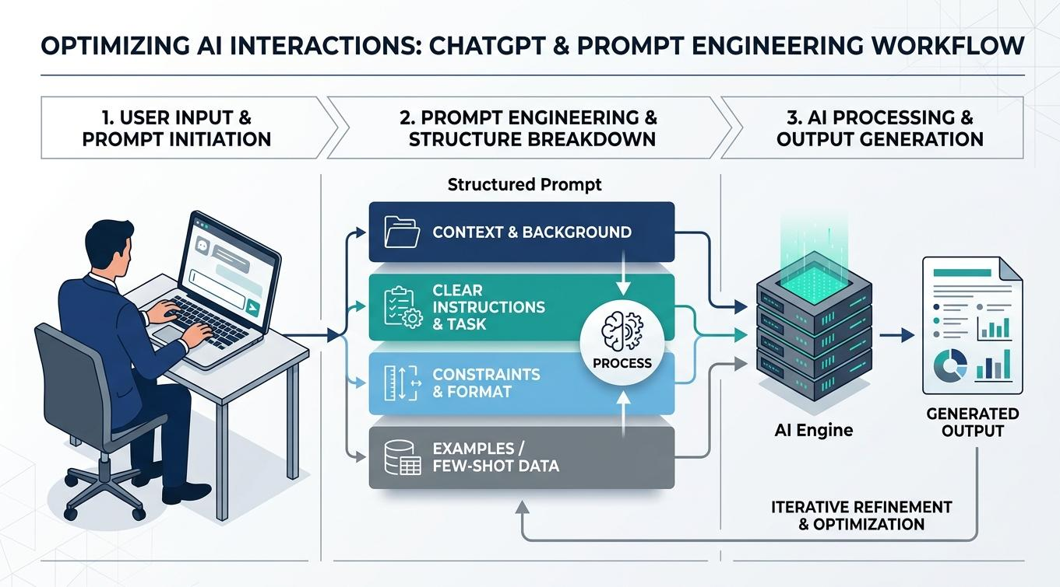

Automation Using AI
AI can automate repetitive tasks.
Examples
Task | AI Automation
Email replies | Auto-generated responses
Data entry | Automated extraction
Invoice processing | OCR + AI
Customer support | Chatbots
Report generation | AI-generated reports
Benefits
- Reduces manual work
- Faster execution
- Higher accuracy
- Cost savings
Image: AI Automation
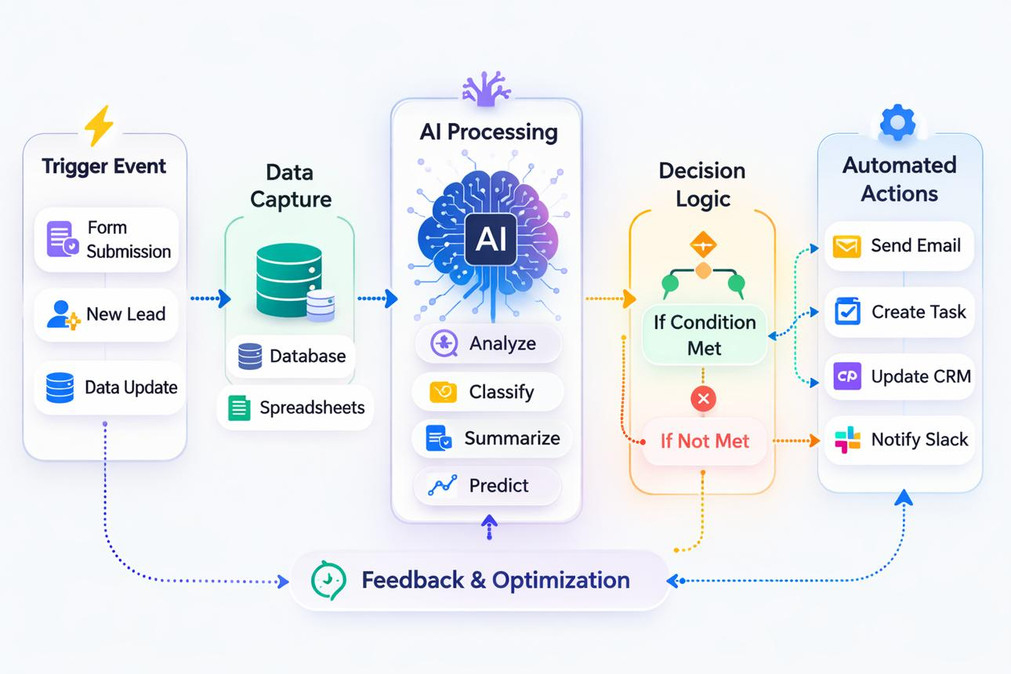
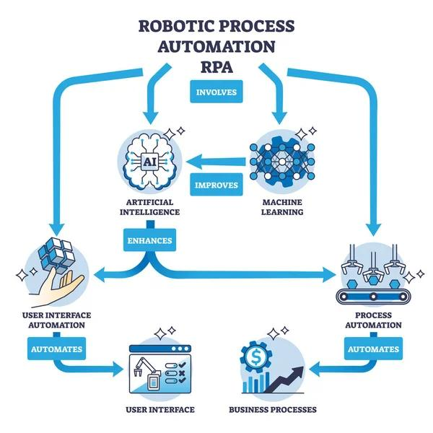


4.3 Data + AI Integration
Using AI in Excel
Features
- Analyze Data
- Forecast Sheet
- Formula Suggestions
- Data Insights
Example
Sales Data:
Month | Sales
Jan | 10000
Feb | 12000
Mar | 15000
Analyze Data automatically identifies trends and patterns.
Steps
- Open Excel.
- Select data.
- Click Home → Analyze Data.
- Review generated insights.
Image: AI in Excel
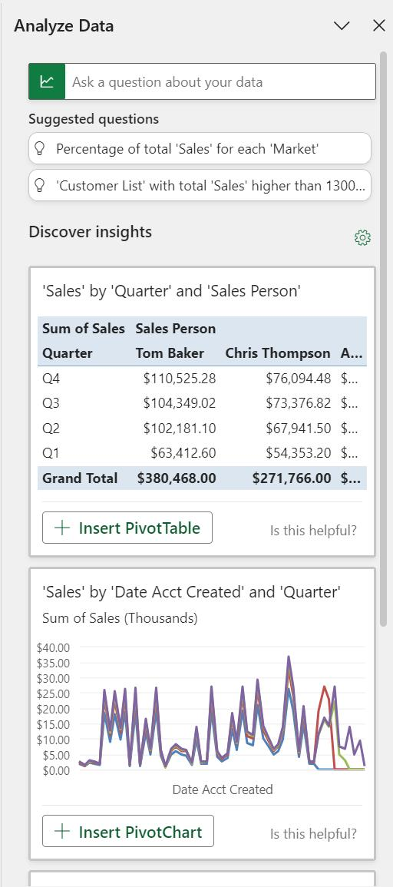
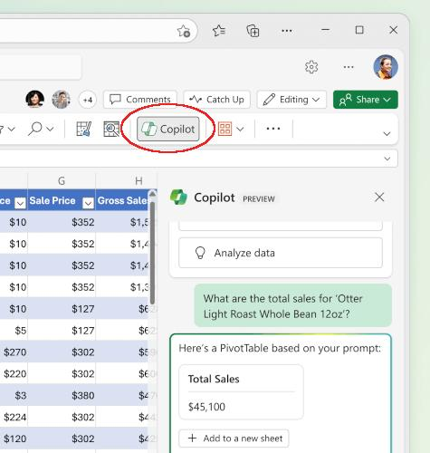
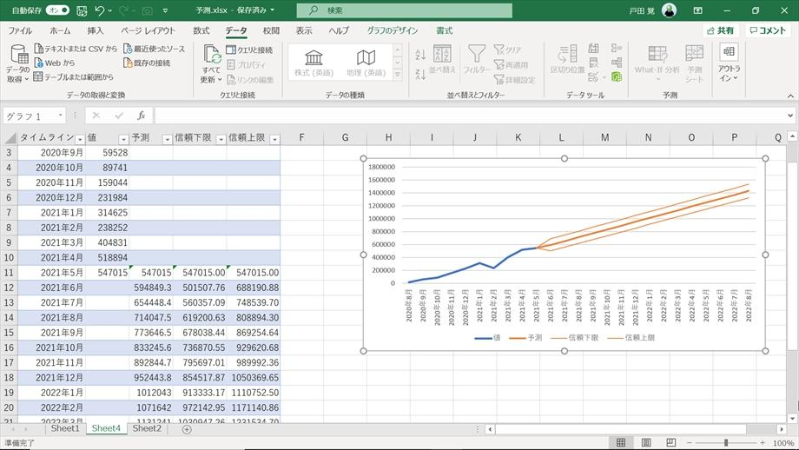

Using AI in Power BI
AI Features
- Key Influencers
- Smart Narratives
- Q&A Visual
- AI Insights
Example
Question:
Why did sales increase in March?
Power BI AI identifies factors contributing to higher sales.
Steps
- Load data into Power BI.
- Add Key Influencers visual.
- Select metric to analyze.
- Review AI-generated insights.
Image: AI in Power BI
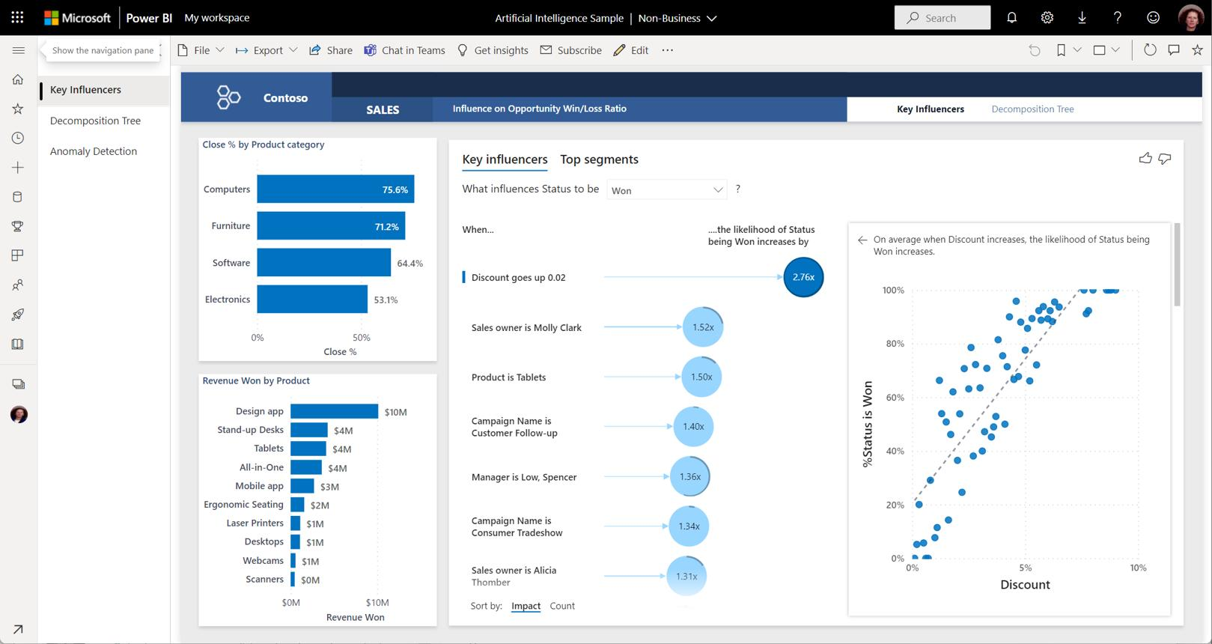
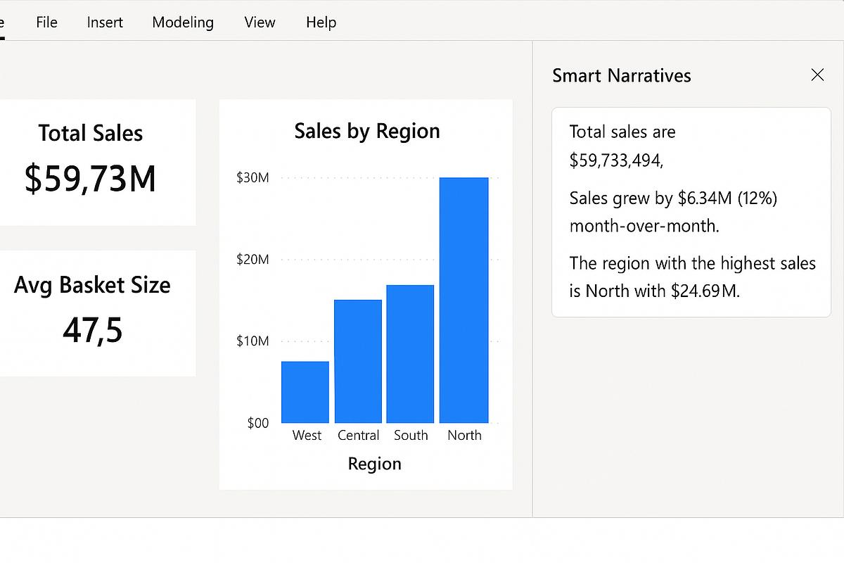
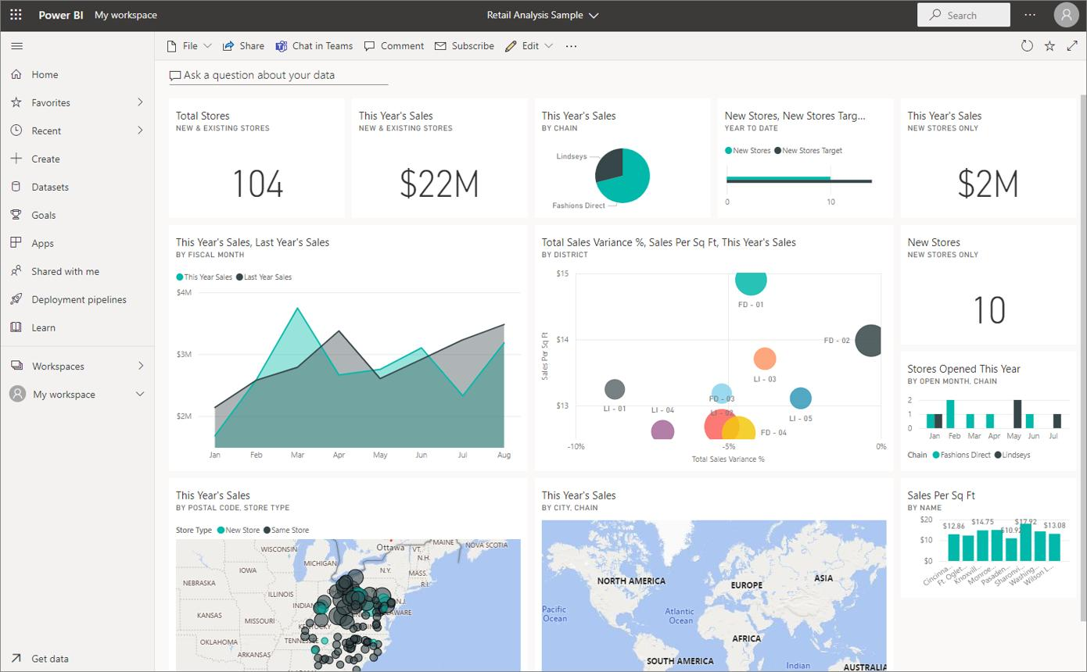

Predictive Insights
Predictive analytics uses historical data to predict future outcomes.
Examples
- Future sales prediction
- Demand forecasting
- Customer churn prediction
- Stock forecasting
Example
Historical Sales:
Year | Sales
2022 | 100000
2023 | 120000
2024 | 140000
AI predicts:
2025 Sales = 160000
Benefits
- Better planning
- Reduced risks
- Improved decision-making
Image: Predictive Analytics
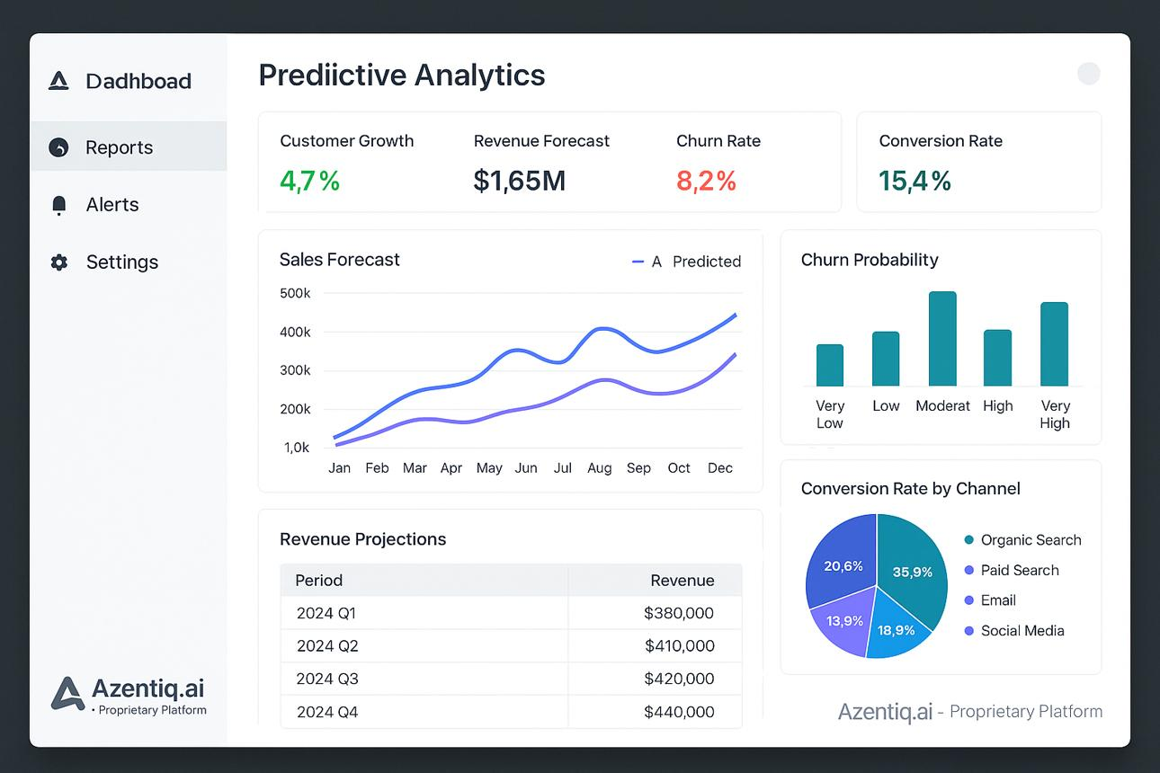
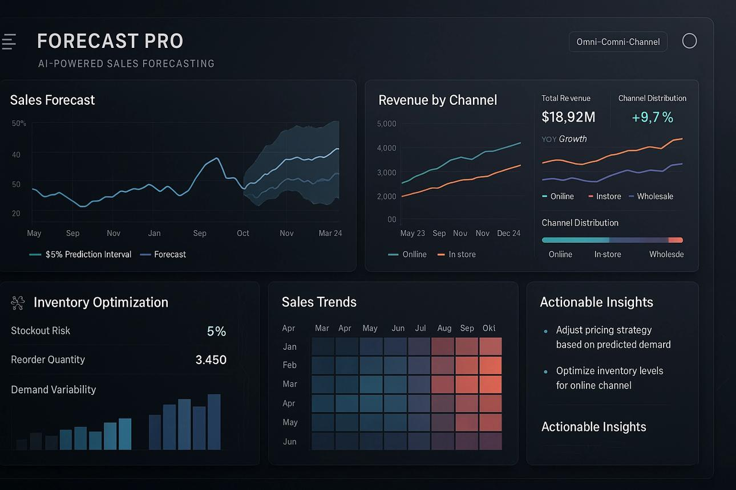
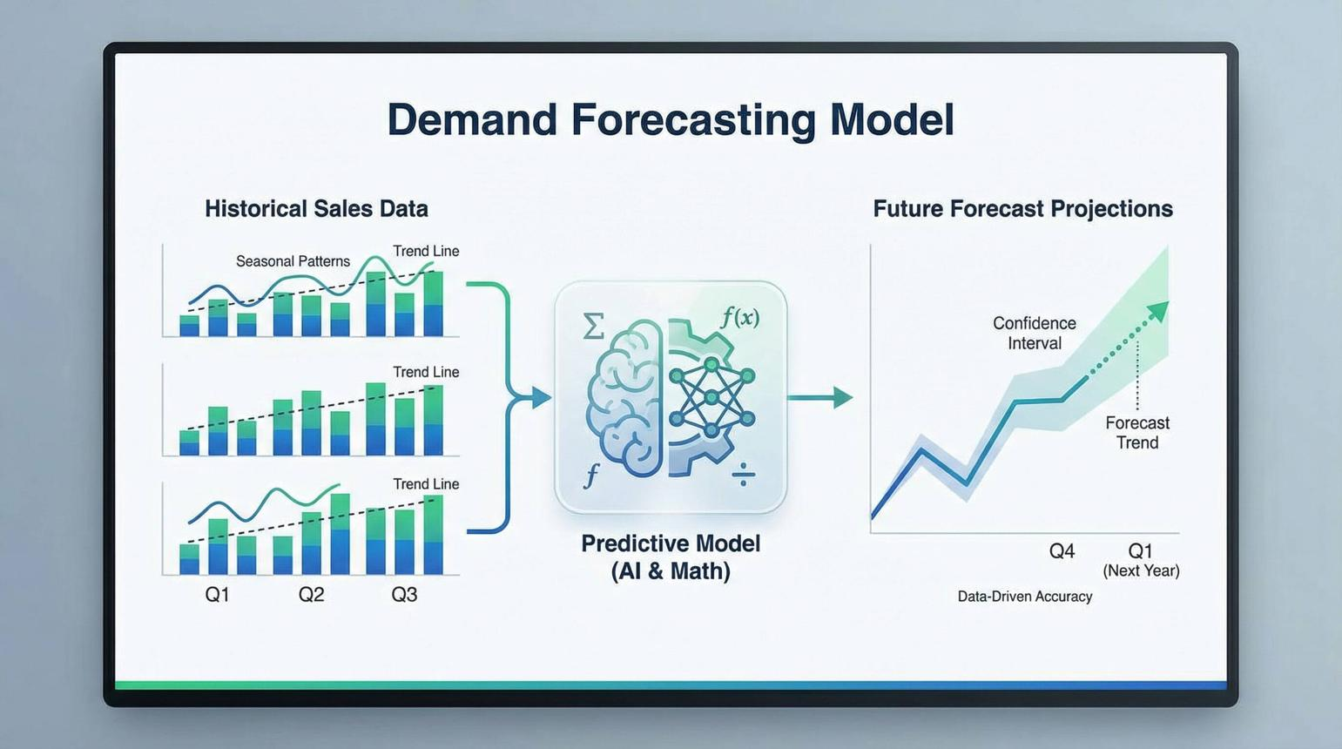

4.4 Business Use Cases
Sales Forecasting
Sales forecasting predicts future sales using historical data.
Example
Month | Sales
Jan | 50000
Feb | 60000
Mar | 70000
AI predicts April sales based on trends.
Benefits
- Inventory planning
- Revenue planning
- Budget management
Image: Sales Forecasting
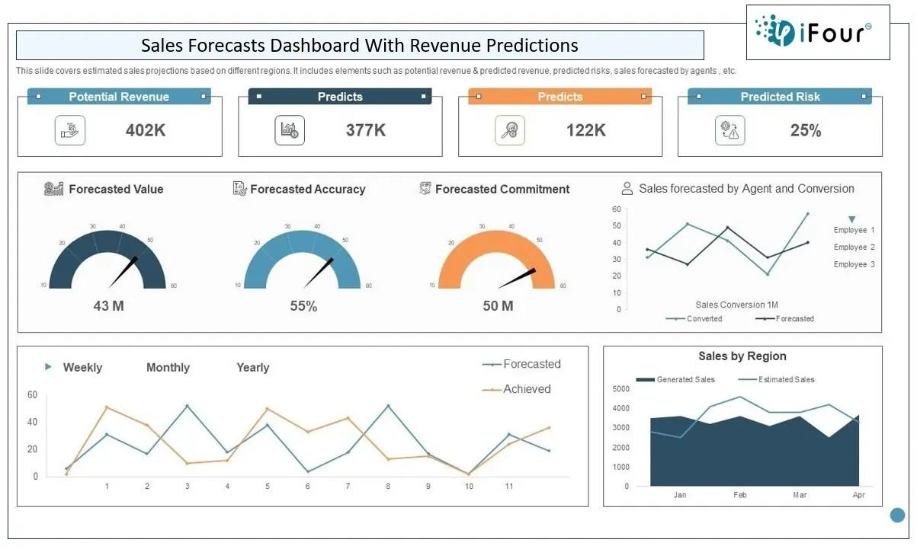
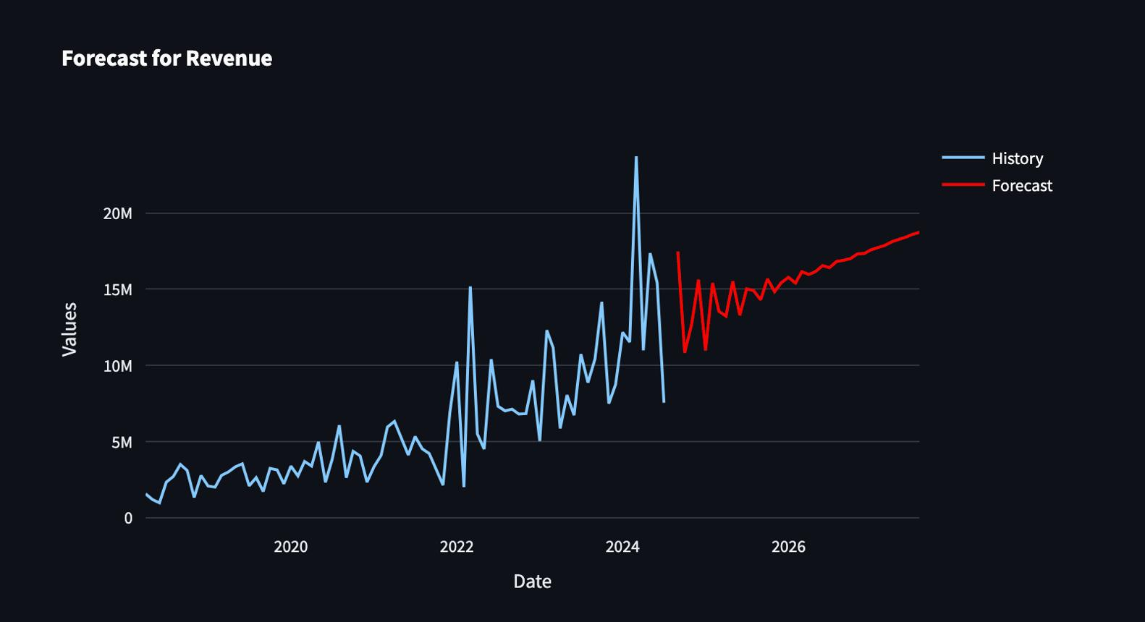


Customer Segmentation
Customer segmentation divides customers into groups based on behavior and characteristics.
Example
Customer | Segment
Customer A | Premium
Customer B | Regular
Customer C | New
Benefits
- Personalized marketing
- Better customer experience
- Increased sales
Image: Customer Segmentation
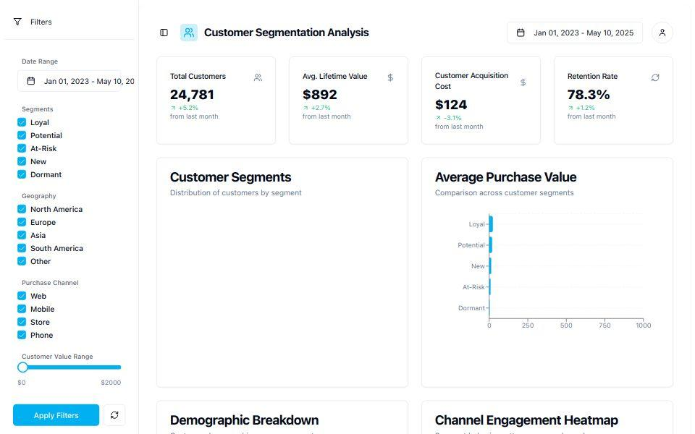
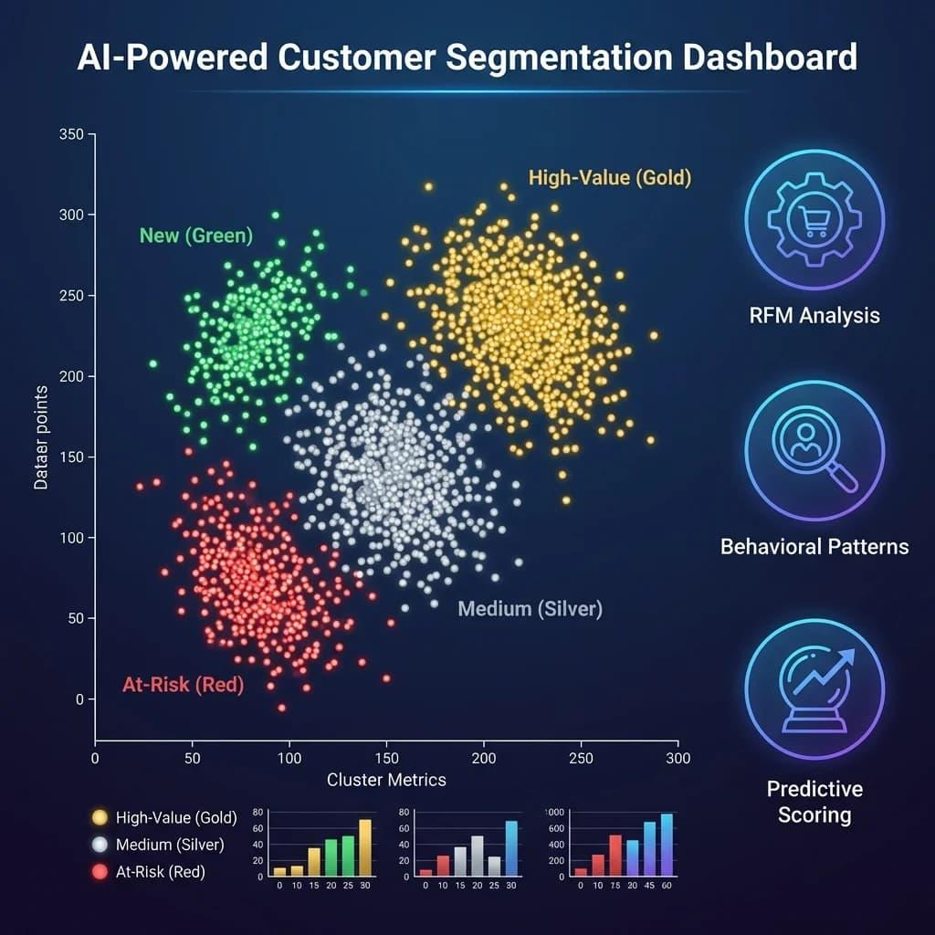
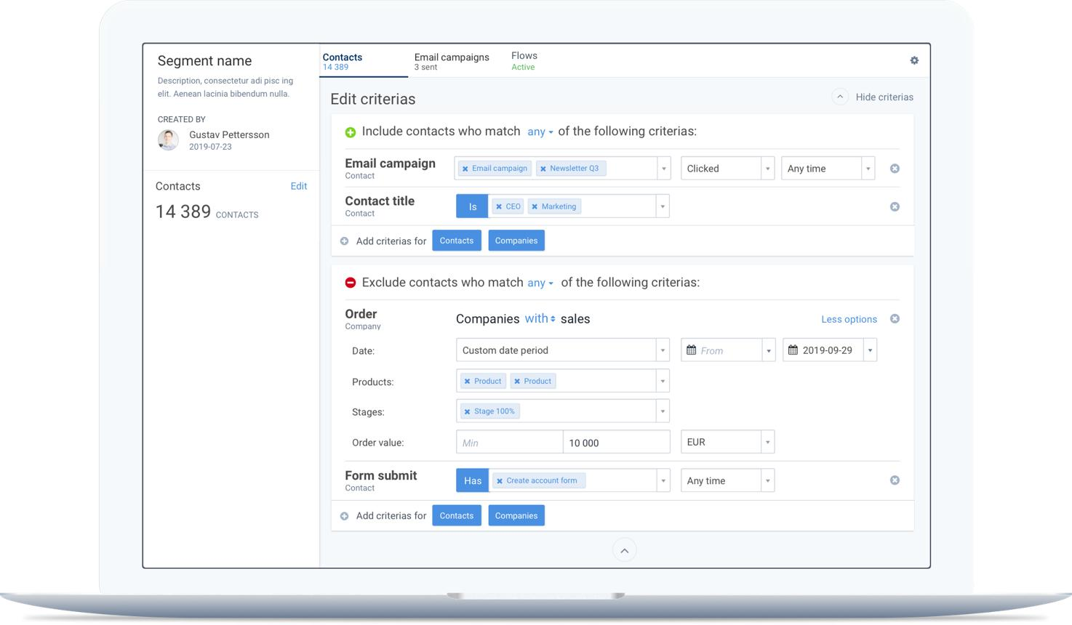

Process Automation
Process automation uses AI to automate repetitive business activities.
Example Workflow
- Customer submits form.
- AI validates data.
- System creates record.
- Email notification sent automatically.
Benefits
- Reduced errors
- Faster processing
- Lower operational cost
Real-World Examples
- HR onboarding automation
- Invoice processing
- Leave approval workflows
- Customer ticket management
Image: Process Automation
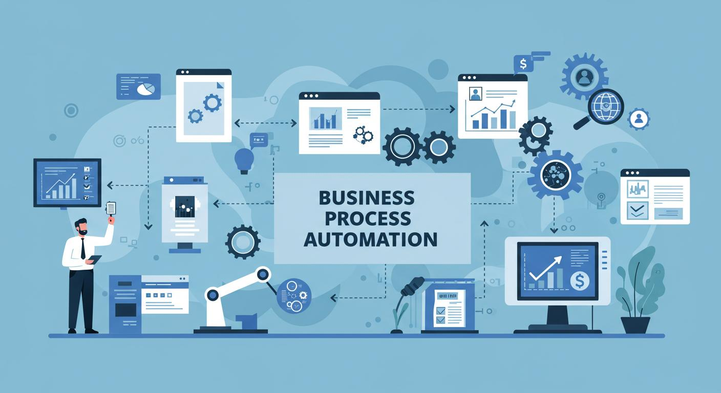

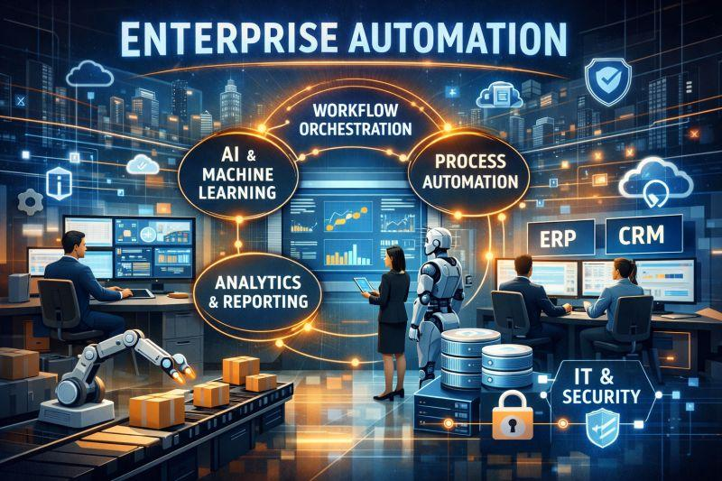
Key Takeaways
✅ AI helps businesses make smarter decisions.
✅ Machine Learning learns from data.
✅ Generative AI creates content.
✅ AI tools improve productivity and automation.
✅ Excel and Power BI provide AI-powered insights.
✅ AI supports sales forecasting, customer segmentation, and process automation.
✅ Predictive analytics helps businesses plan for the future.

